
Vel Tech Rangarajan Dr. Sagunthala R&D Institute of Science and Technology
School of Computing
Department of Computer Science and Engineering

10211CS224 / FULL STACK APPLICATION DEVELOPMENT (JAVA)
PROJECT REVIEW : MILESTONE PROJECT – 2 Date: 22-04-2026
Real-Time Ticket Booking Application

SDG: SDG 9 – Industry, Innovation and Infrastructure

Presented By:
M.JAHNAVI – VTU24536– 23UECS0275
Courses Handling Faculty:
Dr.S.Hemamalini , M.E,Ph.D.,
Assistant Professor (senior grade)

Background of the Problem

INTRODUCTION

Many departments still manage event ticket booking manually, leading to issues like overbooking, data errors, slow service, poor record keeping, and lack of real-time information for participants.
1

Why This Project is Important
Event Ticket Booking System automates the booking process by reducing manual work, improving booking accuracy, managing participant data efficiently, and providing a better user experience.
2

Real-World Relevance
3
This system can be used in colleges, universities, corporate offices, and organizations to manage event registrations efficiently, maintain accurate records, and enhance user satisfaction.
4

System Overview
5
Event Ticket Booking System is a digital solution designed to manage internal department event bookings efficiently.
6

Key Features:
7
- Event listing & details display
- Online ticket booking system
8
- User registration & login
9
- Booking management & history
- Automated ticket generation
- Notifications & booking confirmation

PROBLEM STATEMENT

Problem Statement
1
- Many departments still manage event ticket booking manually.
- Manual processes lead to overbooking and data errors.
2
- Organizers struggle to track participant registrations and seat availability.
- Users face delays and lack real-time booking information.
3
- Record keeping is time-consuming and prone to data loss.
- Lack of automation reduces efficiency and user experience.
4
- Managing multiple events becomes difficult without a proper system.
5
- A simple and reliable digital solution is needed.
- Event Ticket Booking System is proposed to automate booking and improve accuracy.
6

7
8

OBJECTIVE(S)

Objectives
1
- To design and develop an automated Event Ticket Booking System for managing event listings, bookings, and user data.
2
- To improve booking accuracy and track participant registrations through real-time updates and reports.
3
- To implement the system for efficient ticket booking, user management, and event handling.
- To evaluate the performance of the system by monitoring booking accuracy, system reliability, and processing speed.
4
5
6
7
8

PROPOSED SYSTEM

Proposed Solution & Advantages
1
- Event Ticket Booking System is a digital solution that automates event booking, user management, and ticket generation.
2
- It replaces manual registration with a centralized and secure database system.
3
- The system provides real-time updates on seat availability to prevent overbooking.
- Automated booking and ticket generation reduce errors and save time.
4
- User details and booking history are stored for better management and future reference.
- Reports help organizers track event participation and performance.
5
- The system improves user experience by providing fast and easy booking.
- Compared to manual methods, it ensures accuracy, reliability, and efficient event management.
6

7
8


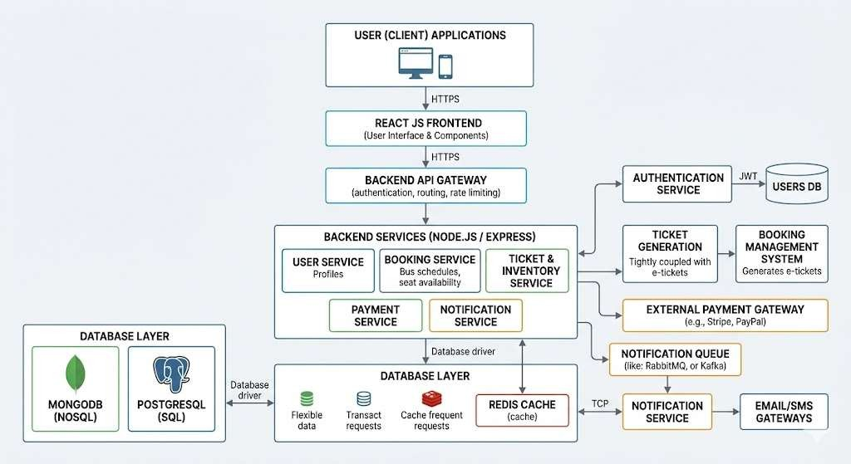
PROPOSED SYSTEM ARCHITECTURE
5
3
1
4
2
7
6
8
9

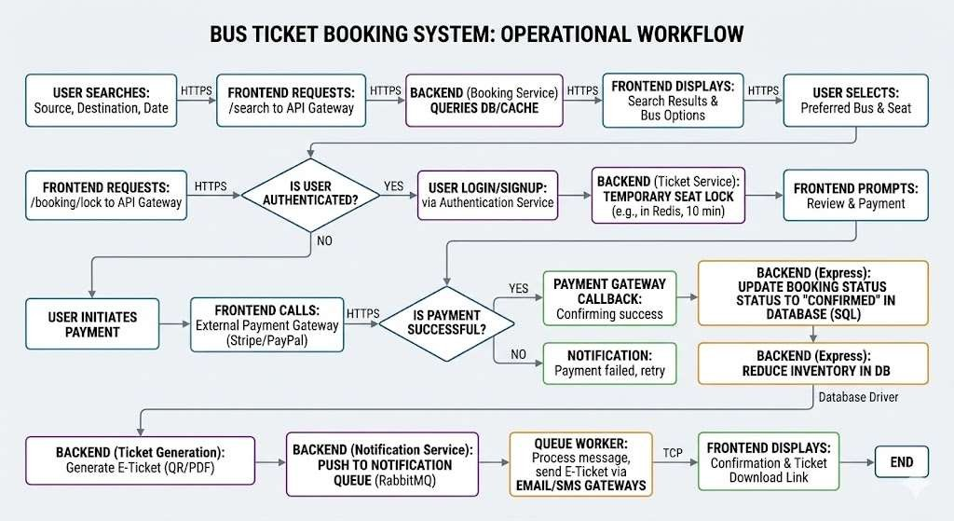
WORKFLOW
6
3
1
4
2
7
5
8
9

TECHNOLOGIES USED

Frontend:
1
- React JS (User Interface)
- HTML, CSS, JavaScript
2

Backend:
3
- Node.js with Express.js

Database:
4
- MySQL
5

Tools:
- VS Code
6
- MySQL Workbench
- Postman (API testing)
7
- Git & GitHub

Hardware/Software Requirements:
- Computer with minimum 4GB RAM
8
- Windows/Linux Operating System
9
- Node.js & MySQL installed
- Web browser (Chrome/Edge)
- Internet connection (for updates & deployment

MODULE DESCRIPTION
Module 1:
User ManagementHandles user registration, login, and secure authentication to control access to the system.
Module 2:
Event & Booking ManagementManages event details, ticket availability, and allows users to book tickets online efficiently. Module 3:
Database ManagementStores user details, event information, and booking records while ensuring data accuracy and security.
Module 4:
Reports & AnalyticsGenerates booking reports, participant summaries, and insights to help organizers manage events effectively.

IMPLEMENTATION SCREENSHOTS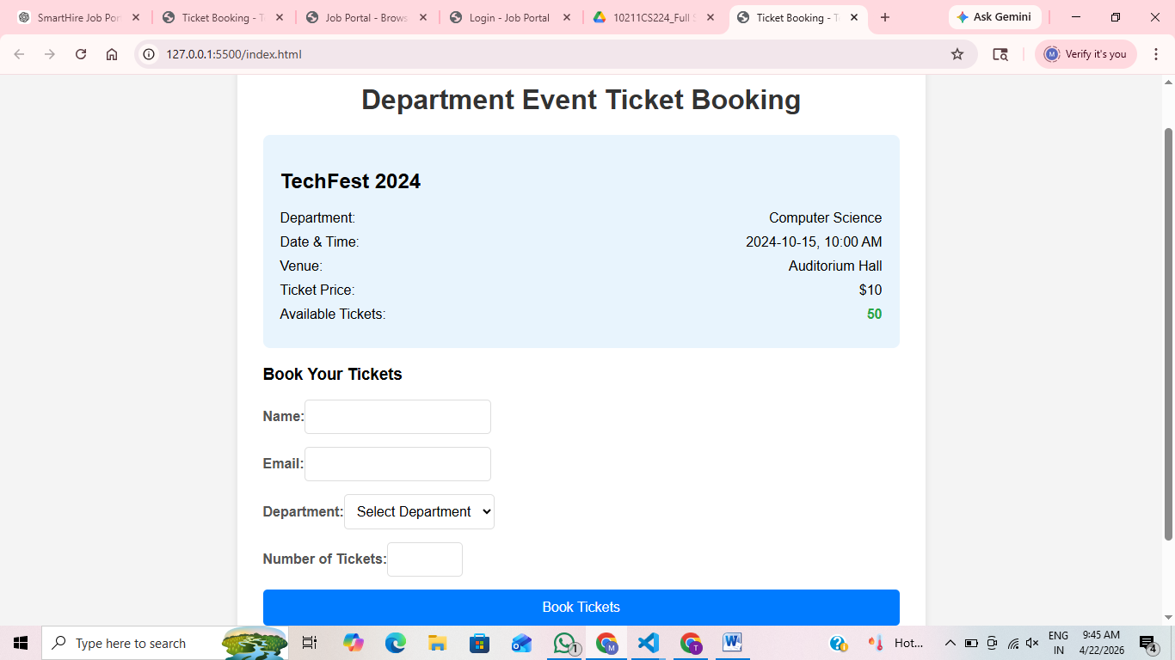
8(C)
3
1
4
2
6
5
7
9

ADVANTAGES & LIMITATIONS

Advantages of Event Ticket Booking System
1
Easy to browse available events in one place.
2
Users can quickly book tickets online without hassle. Simple interface makes it easy for users to navigate.
3
Saves time compared to manual booking or standing in queues.
4

Limitations of Event Ticket Booking System
6
5
Requires internet connection to access the system.
Limited features compared to large commercial ticketing platforms. Payment integration may be limited or basic.
7
8
System performance depends on server and database connectivity.
9

Thank you

